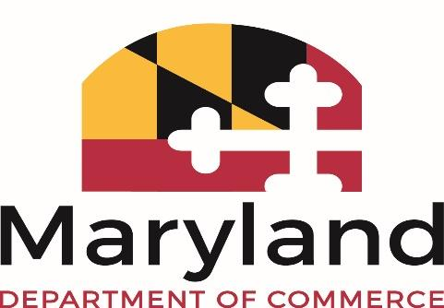

Maryland Marketing Partnership Board of Directors
December 10, 2020 | 3:00 p.m.
*VIA CONFERENCE CALL*

Toll Free: (315) 904-1069
Conference Code: 829862231#
GOOGLE MEETS: https://meet.google.com/kjv-kecy-vaf

MMP MEETING AGENDA

- Call to Order / Roll Call

- Administrative Items
  - Minutes Approval
  - Financial Report (Leonard Raley)
  - Secretary’s Report (Secretary Kelly Schulz)
  - Marketing Report (Carolyn and HZ)
  - Abel Communications (PR Report, Ms. Gina Richmond President, and staff)
  - Partnership and Contract Updates (Rob Scherr)
  - Executive Director’s Report (Tom Riford)

- New Business and Questions

- Next Board Meeting: March 2021 (TBD)

